 | Name of the company: |  | Operating Instructions | Date:
 | Working area:  Clamp silage |  | Activity: Filling, driving, removal | Signature:
 | DESIGNATION
 | Clamp silages
 | DANGERS TO HUMANS AND THE ENVIRNOMENT
 | 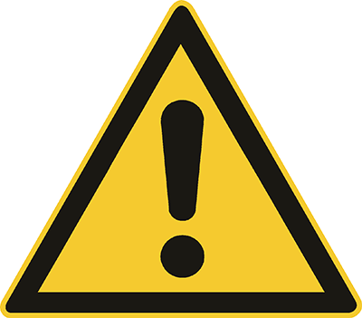 | - Danger from vehicle traffic, vehicle crash.  - Slipping and missing a step when getting on and off vehicles.  - Slipping, stumbling and falling on the silo cover or the slippery silo floor.  - Danger from falling silage masses at the removal point.  - Falling from the cutting edge or the silo wall.  x |  |  | 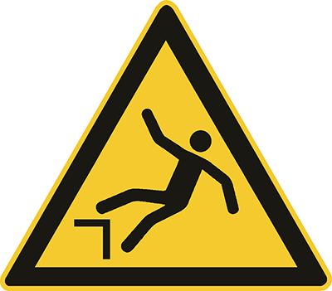
 | PROTECTIVE MEASURES AND RULES OF CONDUCT
 | 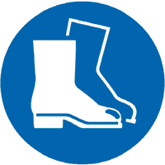  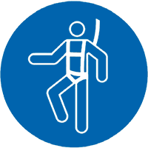 | x  - Prevent unauthorised individuals (onlookers) from entering the silo.  - Employees and other involved parties (e.g. service providers) should receive instruction.  - Wear safety shoes/boots (S3/S5).  - Clean ascents of vehicles for silage or substrate removal regularly!  - Do not jump on to or down from vehicles, e.g. for silage or substrate removal. Climb off backwards  - Only use appropriate removal technology with a driver protection roof.  - Avoid undercuts at the removal location or eliminate them immediately.  - When uncovering the silo foil, a minimum distance of 2 metres from the cutting edge must be maintained. If necessary, suitable aids should be used to retract the film or remove the sandbags/tyres, or mobile railings or rope protection with suitable attachment points are used.  - Mobile silo walls are secured against persons falling inwards and outwards, e.g. by railings or an embankment (vertical distance between the embankment and top edge of the wall 1 m).  - Check protective devices for stability and functionality.  x |  |  | 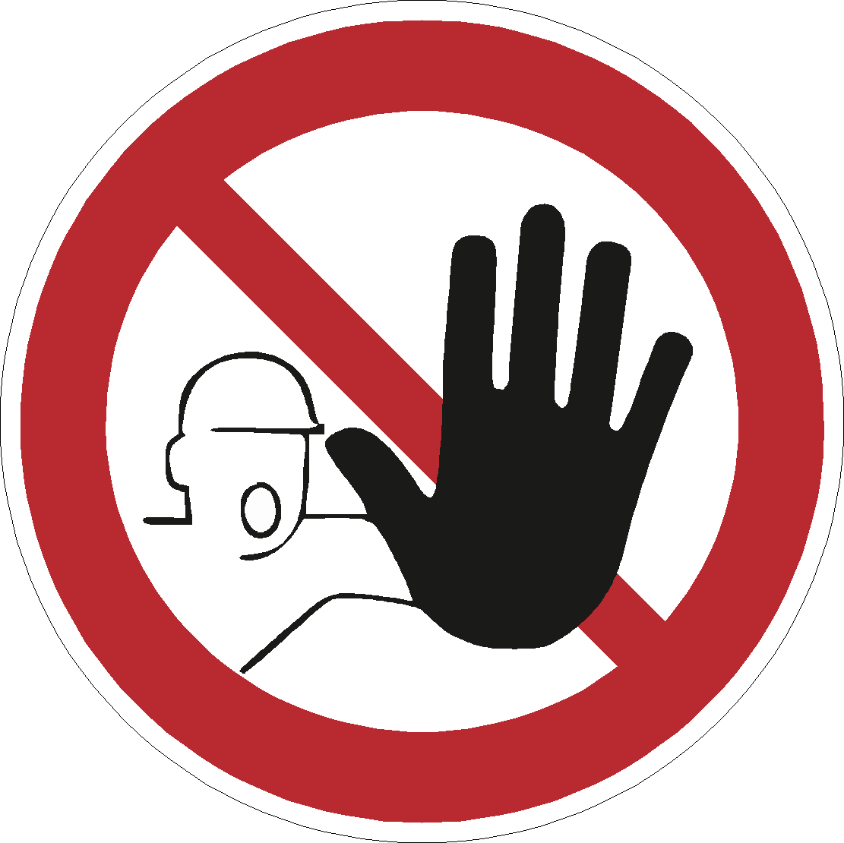
 | WHAT TO DO IN THE CASE OF MALFUNCTIONS
 |  | - Immediately cordon off the danger areas!
 | WHAT TO DO IN THE CASE OF ACCIDENTS – FIRST-AID – EMERGENCY TEL. NO. 112
 | 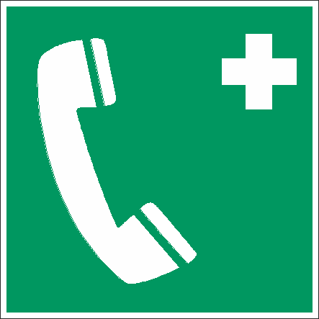 | - Carry out emergency measures at the scene of the accident!  - Call the emergency services/an emergency doctor!  First aider:………………………………………………………………………………………... |  |  | 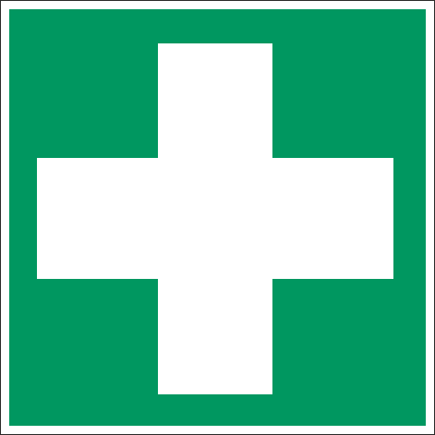
 | Maintenance
 |  | - Replace or repair missing or damaged fall protection devices immediately!
 | CONSEQUENCES OF NON-COMPLIANCE
 |  | - Health consequences: Possibility of very serious or fatal injuries!  x |  |  | www.svlfg.de

